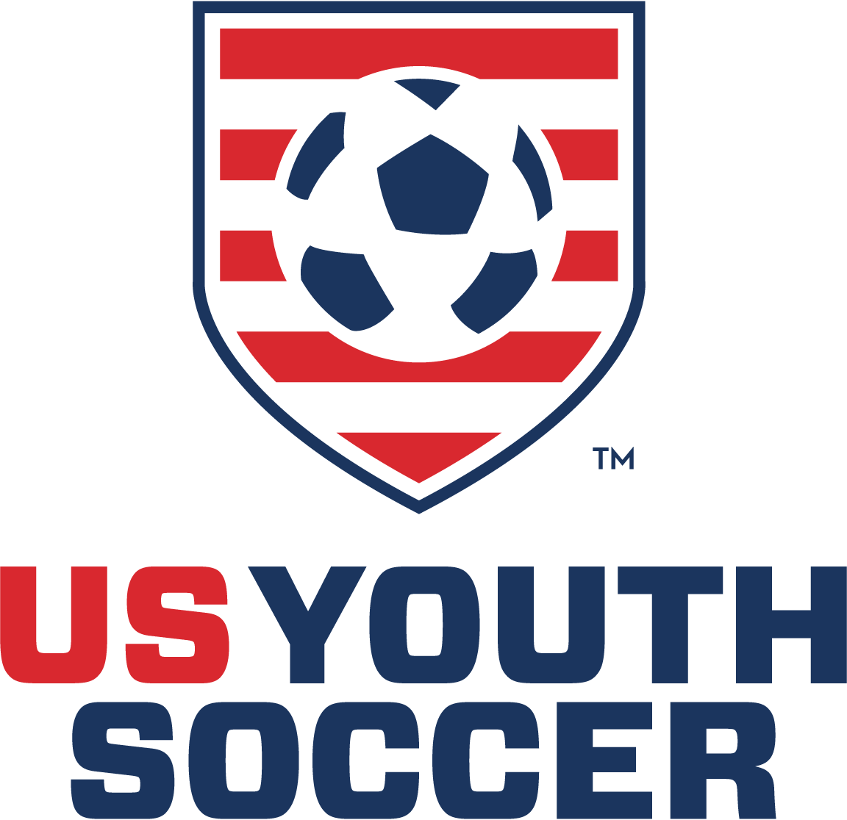

9220 World Cup Way Frisco, TX 75033
USYS National Office
Grassroots Support

Administrative Support
- The approval of a FT position dedicated to the growth of grassroots/recreation soccer.

- Introducing the US Youth Soccer National Grassroots Curriculum (NGC) — the first-of its-kind national player development curriculum for recreational soccer coaches, built by USYS and available exclusively on MOJO. (Fall 2022 & Fall 2023)

- USYS recipient of a Innovate to Grow Grant, from US Soccer: In partnership with the U.S. Soccer Foundation and various state associations, provide a turnkey solution for educators to teach the fundamentals of soccer. (Spring 2023)

- USYS University is the first-ever gathering of educational resources designed to educate members on a multitude of subjects so they can perform better on and off the field of play. With the help of etrainu, USYS has performed a comprehensive implementation process to develop a platform that brings communities together through the power of soccer, creating lifelong fans of the sport. (January 2023)

  - Courses examples include, but not limited to, the following:
    - Welcome to GR Soccer Coaching
    - Recognizing Bias
    - Diversity and Inclusion
    - TOPSoccer

  - Courses just launched in August 2023:
- Developing a Great Team Culture
- Coaching for Positive Youth Development
- Growth, Maturation & Age Effects in Sport
- Preparing for the Season Ahead
- Guided Discovery in Action

- USYS announced that it will host the 1st annual 2023 Grassroots Symposium (September 29-October 1, 2023), further building on the success of previous efforts to support outreach organizations to grow the game in all communities.

- USYS hosted 2 US Soccer DOC Licenses, specifically for the state technical directors, as an opportunity for the technical leaders to obtain the license, reinforcing our commitment to the state associations. A 3rd license has been launched in the Fall 2023, with an accent on NL Club Leaders.

- The creation of League America, a brand that allows member state associations the latitude to create a program that addresses needs specific to their state, and thus a pathway for growth and continuity. Essentially, more fun and less travel.
- Awarded over $100K in Grants to TOPSoccer for State Associations and clubs. (2021 and 2022)

- Awarded over $100k in Grants to League America “Festivals” (2021 and 2022).

- Improving connectivity with State Leadership through webinars, AGM/GBM presentations.
  - Tom Condone – North Carolina, January 2023
  - Daniel Radford – Cal South, July 2023
  - Future presentations:
    - Sari Rose; Oregon and North Texas (September 2023)
    - Tom Condone; Iowa (September 2023)
  - It should be noted that Tom Condone made presentations to Arkansas, Mississippi, and South Texas, when he was combining as the GM/Director of Grassroots-Player Development (2019-2021)

Referee Support
- The approval of a FT position dedicated to the recruitment, retention, and development of referees, whereby providing education resources of our members.

- Ongoing USYS Website Referee Content Updates (June 2023).

- Partnerships and Presence
  - NFHS Officials Symposium (January 2023 in Indianapolis, IN)
  - CIF Officiate California Day (July 2023 in Riverside, CA)
  - NASO Sports Officiating Summit (August 2023 in Riverside, CA)

- USYS Referee Recruitment “Red-Yellow” Card Initiative (July 2023 – Pilot @ NCS):
  - A Simple Call to Action and Efficient Singular Conduit for Initial Referee Sign Up.
  - Scan QR Code – takes you to USYS Referee State Map Web Page.
  - Click on your State of Residence – takes you to that state’s most known/relevant sign-up page/instructions.
  - Versatility – QR Code can be used on virtually anything / anywhere regardless of state or location.

- Pre-Grassroots / Early Referee Education Module (September 2023).

State Association Administrative Support
- USYS Director of Sport Development works directly with Technical Directors in each State to develop uniform and collaborative grassroots programming.

- USYS created a new position, Director of HR, Compliance, & Participant Safety and one specific function will be to provide HR and Risk Management support to each State Association.

- With a re-populated Marketing & Communications department post-COVID, a focused priority is providing direct marketing and communications support to each State Association. The new website and steaming channel as well as design support to States like North Dakota to update their logo designs are examples of the focus from this department.

- One of the responsibilities of the new CFO, is to build upon the degree of accounting services provided each State Association to allow them to focus more to on-field programming support over in-office administrative duties.

- The role of our Member Services Senior Manager is to provide whatever technical support a State association might need. The development of a new registration and risk management process by USYS in support of North Dakota allow the State to re-launch without any paid staff.

- USYS provides additional administrative support across a variety of demands, such as what was offered throughout the entire process of Ohio North and Ohio South merger.

- USYS is always willing to provide financial aid and loans to States in direct need. The loans provided to Minnesota is one example.

Direct Grassroots Collaboration with State Associations
- Committees – USYS supports a number of committees that have a focus on supporting the development of grassroots soccer in the US.
- Grassroots Soccer
- TOPSoccer
- Diversity and Inclusion
- Risk Management
- Organizational Growth
- Governance and Nominating

- Commercial Partnerships – Many of USYS partners focus significant resources on supporting soccer at the grassroots level. Current and past partners include:
- Target & Snickers - Past
- Dick’s Sporting Goods
- MOJO
- Hospital for Special Surgery
- Better Parenting
- TrueSport
- US Center for Mental Health & Sport
- eTrainU
- GeoSnapShot
- InjureFree
- Office of Disease Prevention & Health Promotion
- National Council of Youth Sports

Education and Training
- Annual USYS Workshops
- Annual Leadership Conference
- Grassroots National Symposium
- TOPSoccer Regional and National Symposiums

National Representation on Behalf of Grassroots
- USYS has provided significant influence within US Soccer to help push revisions to the ITC process.

- USYS is working closely with US Soccer and their DC lobbyists to develop letters to elected officials in the House and the Senate to push for revisions to the SafeSport process.

- USYS has provided development and administrative support of US Soccer’s ITG grant program.

- USYS has elected officials representing the interests of all State Associations within the USSF Governance Task Force.
- USYS provides significant resources to create and develop collaborative relations with other youth soccer organizations.
- US Club
- AYSO
- MLS NEXT
- SAYSoccer
- USSSA

- USYS has secured national representation and leadership within US Soccer to provide a strong voice to US Soccer on behalf of all State Associations.
- US Soccer Board of Directors
- US Soccer Youth Council
- Various US Soccer Committees

- USYS leadership has helped create industry-wide partnerships and program development in conjunction with US Soccer Athletes Council to support the growth of emerging disciplines, such as Beach Soccer.

