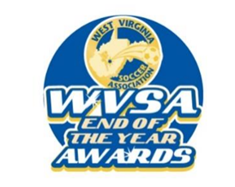
2025 WVSA End Of The Year Awards
The West Virginia Soccer Association wants to honor those that have given back to our sport during the year. WVSA will begin accepting nominations beginning August 15, 2025. The deadline is October 15th, 2025, by 5PM. Just fill out the form below and email it to Kristi@wvsoccer.net or mail it to: WVSA c/o WVSA EOTY Awards, 196 Joe L Smith Dr, Beckley, WV 25801.
CATEGORY OF NOMINATION (check one):
Competitive Coach of the Year (GIRLS) _________ Competitive Coach of the Year (BOYS): _________ Grassroots Coach of the Year (GIRLS): _________ Grassroots Coach of the Year (BOYS): ________ Volunteer of the Year: ________ Administrator of the Year: _______
TOPSoccer Buddy of the Year: _______ Young Male Referee of the Year: _______
Young Female Referee of the Year: _______
Name of Person You Are Nominating: _
Nominee’s Email:
Nominee’s Cell:
Person Submitting Nomination Name:
Person Submitting Nomination Email:
Person Submitting Nomination Cell:
Send us the reason why this person should win this award (200 word or less).
By agreeing to send in this nomination, you agree to fill out the official USYS Awards Nomination Form if your nominee wins the WVSA State Award. This includes an information form, multiple essay-type questions that need to be answered (400 words or less for each question), as well as providing letters of recommendation (maximum of 3). These MUST be submitted to Kristi Acord by September 16, 2025, to be considered for the regional and national awards. If this information is not completed by the person submitting the nomination, the winner will not be eligible for the regional and national competition. NO EXCEPTIONS! _______________________________________________________________________
Signature of Person Submitting Nomination:
Date

