2026 AGM Election

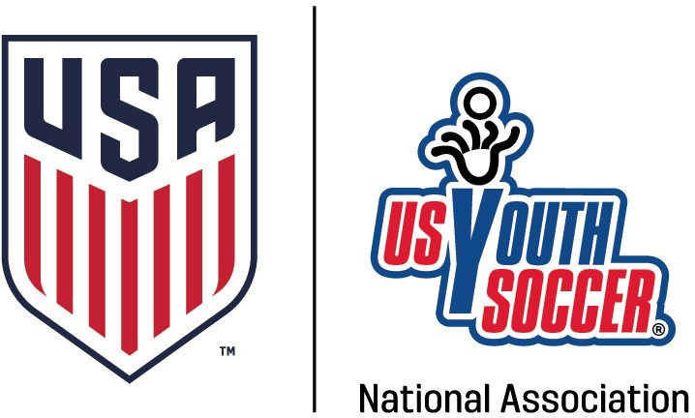
All nominations must have the written approval of the nominee. All nominees must have current All Risk Management and Safe Sport Certifications. Nominations must be submitted to WVSA by 2/22/2025
OFFICE | INCUMBENT | NOMINEE | NOMINATION SUBMITTED BY
President | Randall Coleman | Randall Coleman | Lloyd McIntyre
VP Youth | Jeff Cox | Jeff Cox | Lloyd McIntyre
District 2  Commissioner | Bob Kolanko | Jessica Watts | Joe Pepe
District 4  Commissioner | Chris Kessel | Rachel Cipoletti | Travis Callihan
District 6  Commissioner | Rick George | Rick George | Jeff Cox
Secretary/Treasurer | Bill Sumpter
At Large Adult | Rob Price | Chris Kessell | Aaron Wood
Affiliated with the United States Soccer Federation, United States Youth Soccer Association, and United States Amateur Soccer Association PO Box 3360 - Beckley, WV 25801
(304) 252-9872 - (800) 894-9872 - (304) 252-9878 Fax Web Site: www.wvsoccer.net
West Virginia Soccer Association
WVSA Board of Directors Nomination Form 2026
I / We ____________________________Nominate __________________________ of ___________________ for the WVSA Office of ____________________________ for the 2026-2028 Term.
Nominee acceptance of nomination I agree to serve if elected. __________________
Background Check Completed _______________________
Safe Sport Certificate Completed _____________________
All Required Risk Management Certification Completed _________________
Please submit this completed form to kristi@wvsoccer.net by 2/1/2026 Nominee acceptance may be by separate email.
Affiliated with the United States Soccer Federation, United States Youth Soccer Association, and United States Amateur Soccer Association PO Box 3360 - Beckley, WV 25801
(304) 252-9872 - (800) 894-9872 - (304) 252-9878 Fax Web Site: www.wvsoccer.net

